DDOS ATTCK ON POX CONTROLLER

Introduction to DDoS Attacks and Their Impact on POX Controllers
1. Understanding DDoS Attacks
A Distributed Denial-of-Service (DDoS) attack is a type of cyber-attack where multiple compromised devices (often part of a botnet) flood a target system with a massive volume of traffic. The goal is to overwhelm the target’s resources, causing it to slow down, crash, or become completely unavailable. DDoS attacks are among the most common and disruptive threats in modern networking environments, affecting websites, cloud services, and Software-Defined Networking (SDN) controllers.
2. Why Target the POX Controller?
In Software-Defined Networking (SDN), the controller plays a crucial role in managing the network by making centralized decisions and distributing them to the data plane (switches). The POX controller, like any other SDN controller, is vulnerable to DDoS attacks because:
- It is a centralized component – If the controller is overwhelmed, the entire network can fail.
- It processes all flow requests – A flood of malicious packets can exhaust its processing power.
- It relies on OpenFlow switches – Attackers can send spoofed OpenFlow requests to degrade performance.
3. How This Attack Will Be Implemented
Following the Cyber Kill Chain model, the attack will be structured into seven stages, with each step documented using screenshots and explanations:
Step 1: Reconnaissance
- Use Nmap to discover the IP address and port on which the POX controller is running.
- Identify open ports that can be exploited for attack.
Step 2: Weaponization
- Prepare hping3 or Scapy scripts to generate a high volume of spoofed packets.
- Modify the attack to include randomized IP and MAC addresses to make detection harder.
Step 3: Delivery
- Deploy the DDoS script from multiple Mininet hosts simultaneously.
- Observe the packet flooding rate towards the POX controller.
Step 4: Exploitation
- Ensure the controller starts dropping legitimate traffic due to the overload.
- Monitor network behavior using Wireshark or tcpdump.
Step 5: Installation
- Not used.
Step 6: Command & Control (C2)
- Not used.
Step 7: Actions on Objectives
- Assess the impact on the SDN network (delays, packet loss, controller crash).
- Capture logs and screenshots to demonstrate the attack’s effectiveness.
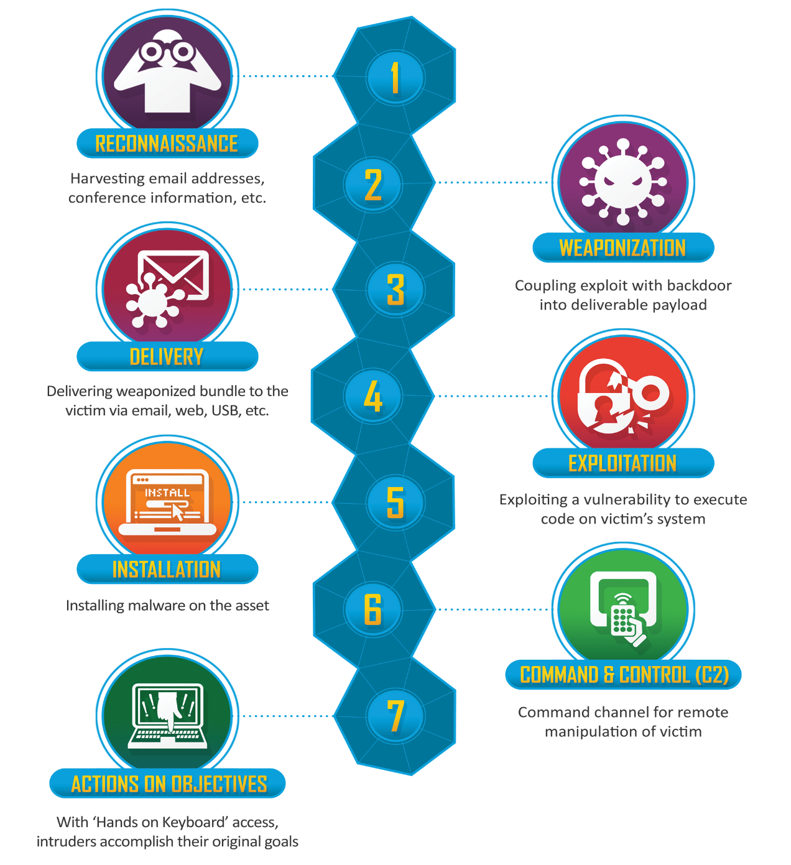
4. Next Steps – Detection & Mitigation
After successfully launching the attack, two detection methods will be tested:
- DDoS Detection using Information Entropy Analysis and Deep Learning
  - Implement an entropy-based approach to detect unusual flow patterns.
  - Train a deep learning model to classify normal vs. malicious traffic.
- SSAE-SVM Hybrid Detection Method
  - Use a Stacked Sparse Autoencoder (SSAE) to extract attack features.
  - Classify attack traffic using a Support Vector Machine (SVM).

Simulation of ddos attack
1. Reconnaissance
We usually use nmap tool to collect information about the target like the ip , open ports, the os of the target and more other information but here in the sdn network we used the pox controller and the Mininet booth in the same machine not separated so let’s start this process and see the outcomes .
First, we will open the cli of any host like h1 and run the following command $ ovs-vsctl show this provides detailed information about the Open vSwitch (OVS) configuration on the host. However, there are some important considerations when running this command inside a Mininet host:
ovs-vsctl is a utility for managing Open vSwitch (OVS) configurations. The show option displays the current OVS state, including:
- Bridges and their associated ports
- Controller configurations (if any)
- OpenFlow versions and settings
- Active network interfaces
So, this Matters for our DDoS Attack because:
1- We need to confirm the switch is connected to the controller (ovs-vsctl show helps with that).
2- Check active interfaces and flow rules before launching an attack.
3- If the controller is overwhelmed, ovs-vsctl show may show disconnections or missing controllers.

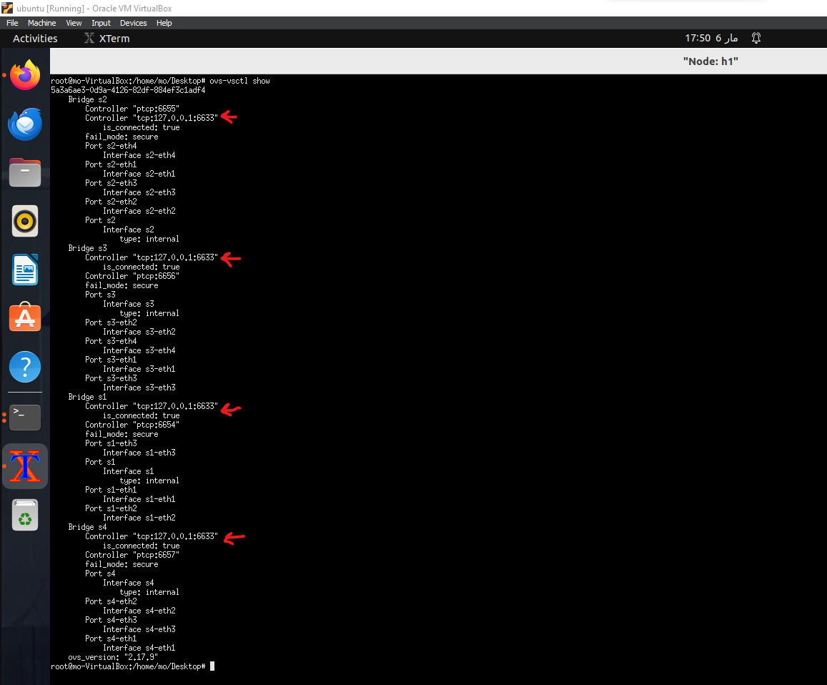
From the output, we can see that all four switches (s1, s2, s3, s4) are connected to the POX controller at 127.0.0.1:6633.
Additionally, each switch has a local passive connection (ptcp:6654, ptcp:6655, etc.), but those are just OpenFlow manager ports for local configurations.
What This Means
- The POX controller is running on 127.0.0.1:6633, and it is correctly connected to the switches.
- Each switch (s1, s2, s3, s4) has multiple interfaces (s1-eth1, s2-eth2, etc.) that are linked to hosts and other switches.

Next Steps to Detect the POX Controller
Since we now know the controller is at 127.0.0.1:6633, let's confirm it with the right approach:
Note : if we run nmap from h1 to confirm that the pox is working in the right ip and port number of the openflow protocol this will not work because we scanned 127.0.0.1 from within h1, which refers to h1 itself and not the Mininet host that holds the pox controller. See this screenshot
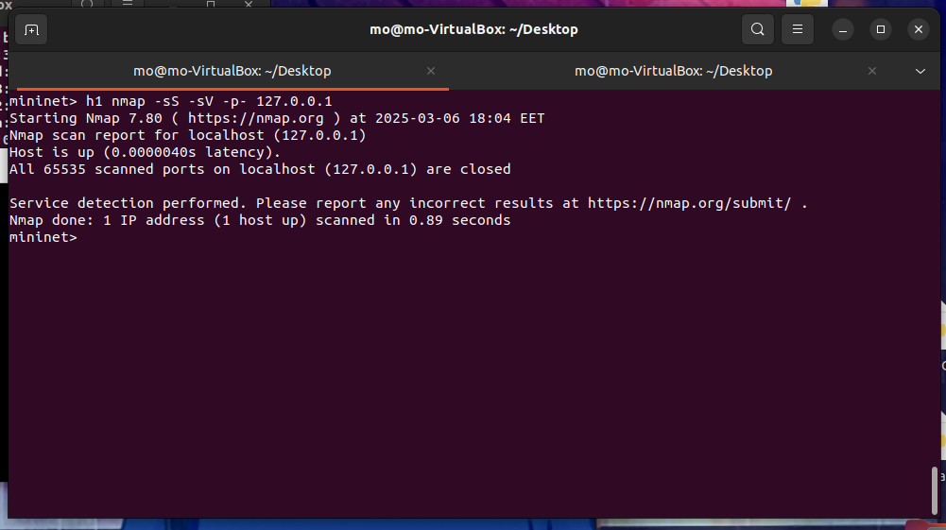
Here is another screenshot
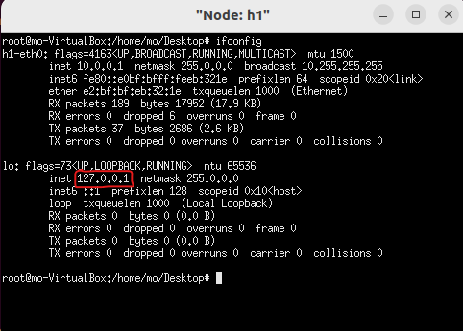
Run Nmap from the Mininet Host (Ubuntu Machine)
Run this from your host terminal (not Mininet CLI):
$sudo nmap -sS -sV -p- 6633 127.0.0.1
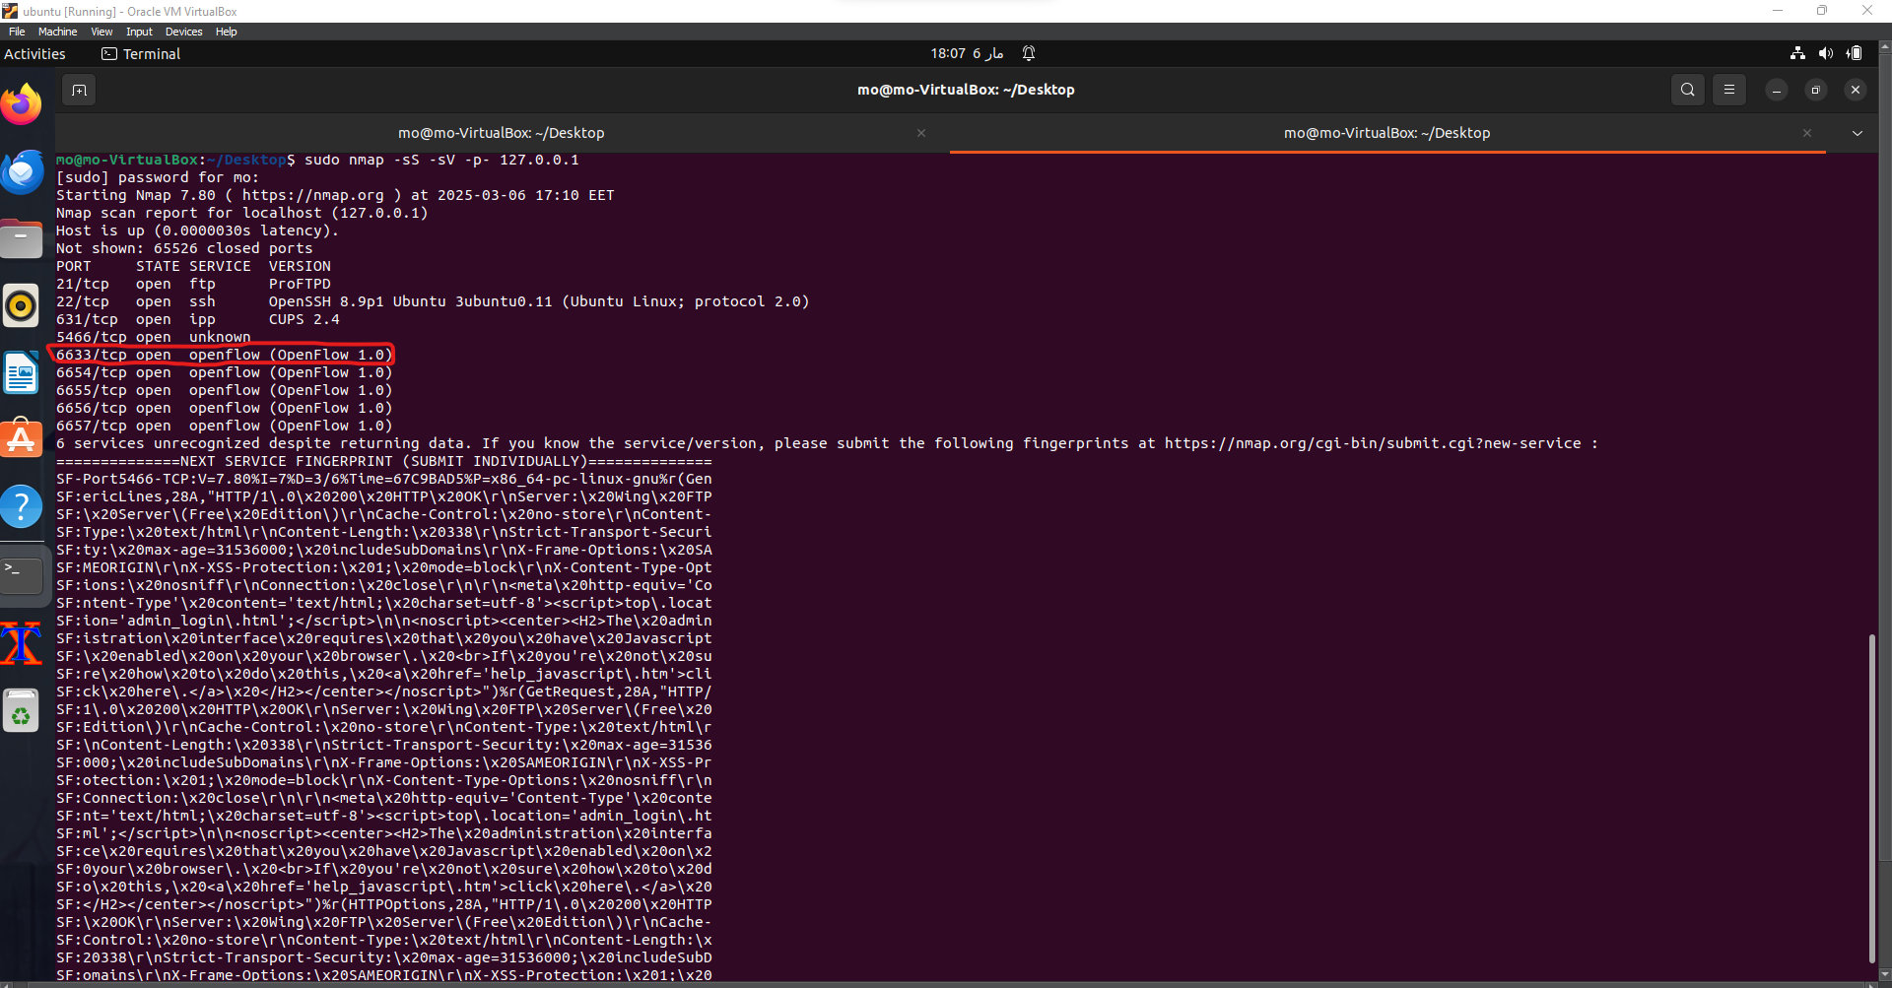
This confirms the POX controller is active and listening.
Since the attacker (h1,h3,h5) now knows the ip and the port number of the controller now he can move to the next phase which is weaponization.

2. Weaponization
The attacker here creates a deliverable payload for the ddos attack using hping3 tool. Here is the command used for the attack
$hping3 -d 300 -S -w 64 -p 6633 --flood --rand-source -V 127.0.0.1
This command should be our payload that initiates the attack when it’s delivered to the target so here is what the command do:
1. hping3:
  - This is the tool being used. hping3 is a network packet crafting tool, useful for security testing and attacks such as DoS.
- -d 300:
  - Data size: Sets the size of the data field in the packet to 300 bytes.
- -S:
  - SYN flag: Sets the SYN flag in TCP packets. This is used to initiate a TCP connection.
- -w 64:
  - Window size: Sets the TCP window size to 64. This parameter controls the amount of data that can be sent before an acknowledgment is required.
- -p 6633:
  - Port: Specifies the destination port number, which in this case is 6633 (where the pox controller is running).
- --flood:
  - Flood mode: Sends packets as fast as possible, generating a high volume of traffic to overwhelm the target.
- --rand-source:
  - Random source: Randomizes the source IP addresses of the packets. This helps in avoiding detection and makes it difficult for the target to filter out the attack packets.
- -V:
  - Verbose mode: Enables verbose output, providing detailed information about what hping3 is doing.
- 127.0.0.1:
  - Target IP: The IP address of the target pox, which in this case is 127.0.0.1.

But as we discussed before the attack will not run with this ip address of the pox controller we changed the ip of the controller to the machine ip address which is 10.0.2.15 and with the same port (6633) and try to do the same steps to see if the attack will work against the pox but it would not.
The Real Reason the Attack on POX Didn't Work
The attack failed despite setting the POX controller to 10.0.2.15 and assigning Mininet hosts IPs in 10.0.2.0/8. Here's why:
Key Fact: POX Does NOT Process Normal Traffic
- POX is NOT a normal network service like a web server or SSH daemon.
- It ONLY processes OpenFlow control traffic, not regular SYN flood packets.

Why did the SYN Flood on POX Failed?
POX Listens for OpenFlow, NOT Normal Packets
- POX only communicates with switches via OpenFlow.
- SYN packets were just dropped by the switch because POX doesn't have a service handling them.
Switches Filter the Traffic
- Attack traffic never reached POX because switches handle normal traffic forwarding.
- Only packets that require a new flow rule are forwarded to POX.
POX is NOT a Host
- Regular DDoS attacks work by flooding network services (e.g., web servers, SSH, or DNS). This will be our concern
- POX does NOT act like a server it just installs flow rules.

The Real Way to Overload POX
Instead of attacking POX directly, attack a host to force POX to process too many flow requests.
New Plan: SYN Flood a Mininet Host (e.g., h7)
- Every new TCP connection request forces the switch to ask POX for a flow rule.
- This overloads POX with too many flow requests → slowing it down or crashing it.

Working Attack Command (Run on h1, h2)
To make the attack more real we will make h7 operate as a web server (http server)
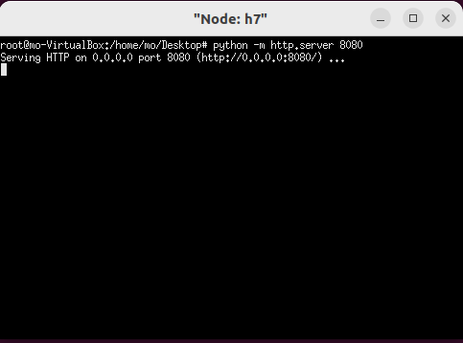
So now if the attacker does some reconnaissance as the first phase using nmap we will see that h7 has an open port which is 8080
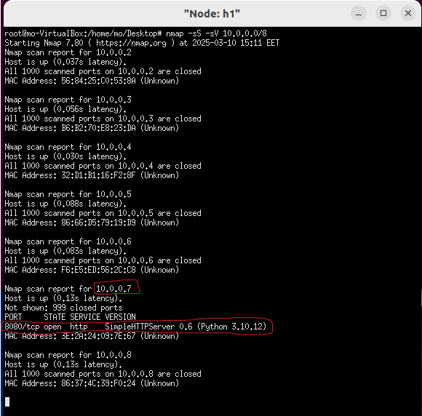
Now we the attacker knows the target ip address and the open port he know can create his payload to attack with as follows:
$hping3 -d 300 -S -w 64 -p 8080 --flood --rand-source -V 10.0.0.7
- This floods h7
- Triggers POX to install excessive flow entries
- Overwhelms POX, causing delays or failure
Now the attacker moves to the third phase which is the delivery phase.

3.Delivery
The attacker goal here is to Deliver the weapon to the target environment as follows:
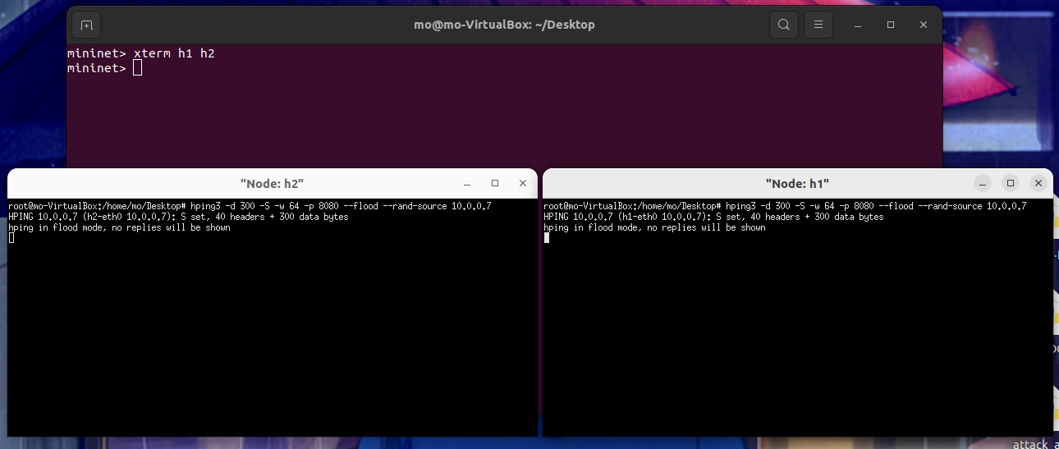
Here are several ways for detection when delivering the attack:
a. Using Wireshark
We will capture it on the loopback interface because we need to see all the traffic that will walk through the pox controller
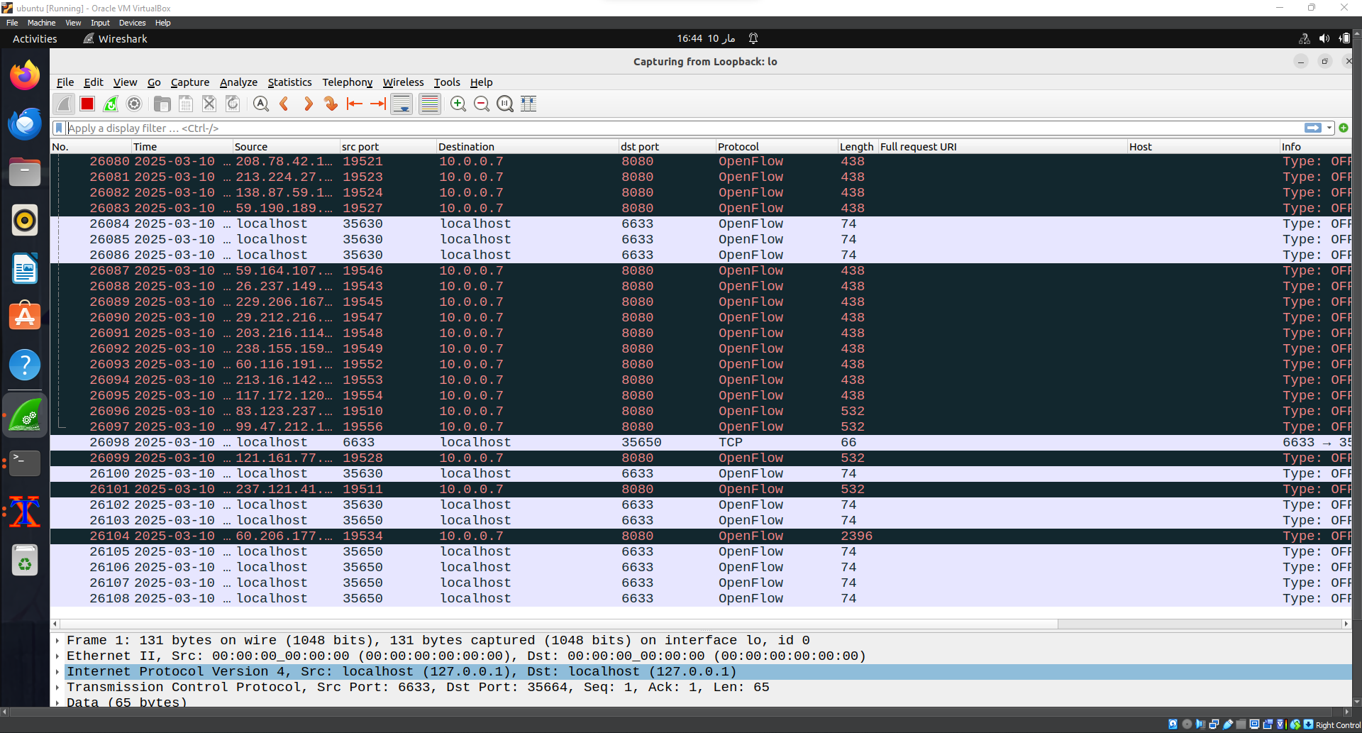
If we select any random openflow packet as the following we will see in the transport layer where the syn packet exists that the packet comes from random port and random ip to the controller port which is 6633.
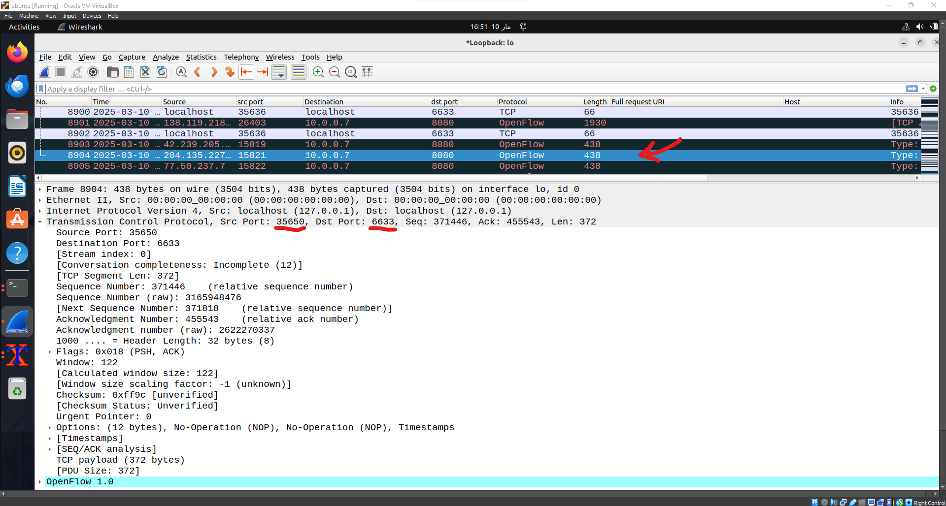
b. Using tcpDump
we will capture on the same interface using this command:
$tcpdump -i lo -nn
Explanation:
- sudo → Runs tcpdump with root privileges (required for packet capture).
- tcpdump → The packet capture tool.
- -i lo → Specifies the loopback interface (lo).
- -nn → Disables hostname and port name resolution (shows raw IPs and ports for better speed and clarity).
It shows the same result.
Note : we see that the src and dst ip is loopback that’s because we capture on the loopback interface, if we capture on the targeted web server we will see the real ip address .know that we capable of to see it in Wireshark but in tcpdump we can’t.

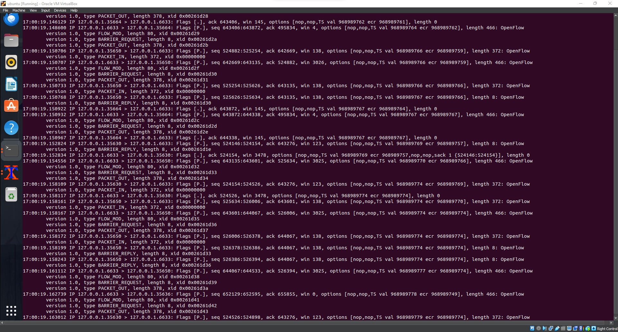

c. using flow tables on on s1 and s4
running the following command will show up the flow table on s1:
$ovs-ofctl dump-flows s1
As we see here there are a pig traffic that send from random src ips and random ports to the web server ip in 8080 port in very short duration time.
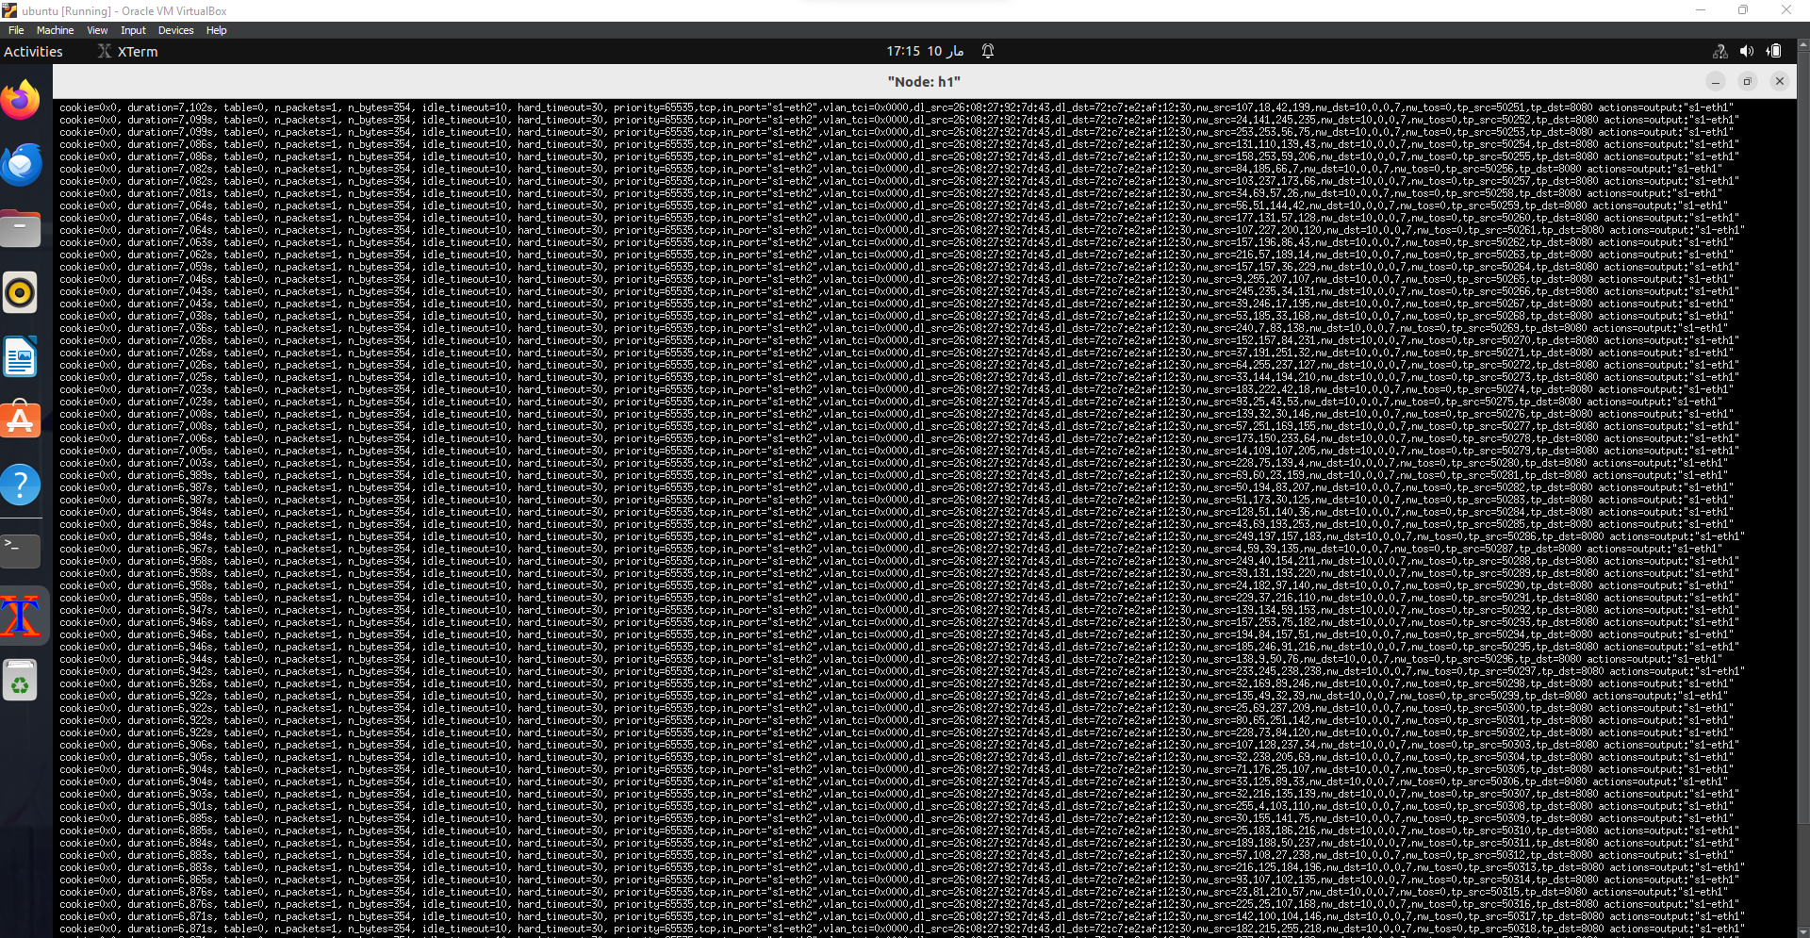
d. Controller logs
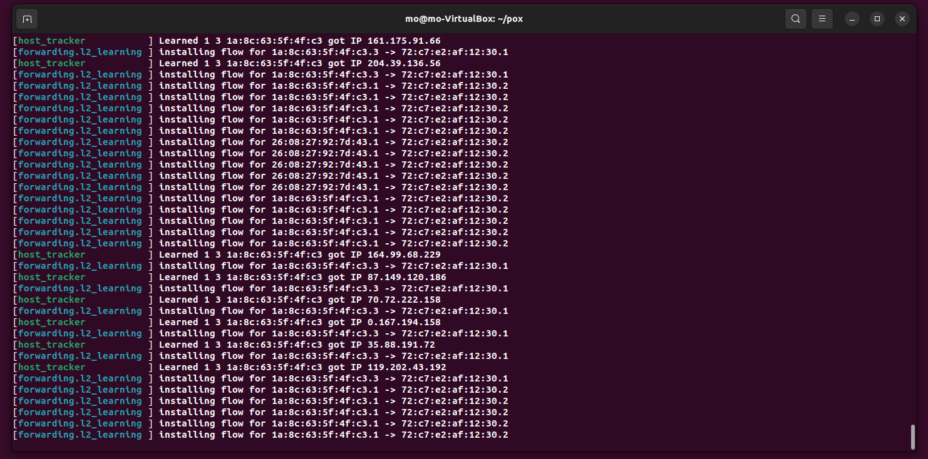
We see that the controllers are flooded with many requests while the attack is running, and the controller is continuing in installing flows ion switches.
Now after delivery processes we go to the exploitation process to Overwhelming h1’s resources.
3. Exploitation
Here we Trigger the payload on the target system as we did to overwhelm its resources
- Action: Initiate the SYN flood attack from h1 and h2 to h7 using the hping3 command.
  - hping3 -d 300 -S -w 64 -p 8080 --flood --rand-source -V 10.0.0.7
- Mechanism: Flood h7 with SYN packets to create numerous half-open connections, exhausting its resources.
- Impact:
  - Resource Exhaustion: CPU, memory, and network bandwidth on h1 are consumed by the attack, causing a denial of service.
  - Service Unavailability: The HTTP server on h7 becomes unresponsive to legitimate requests.
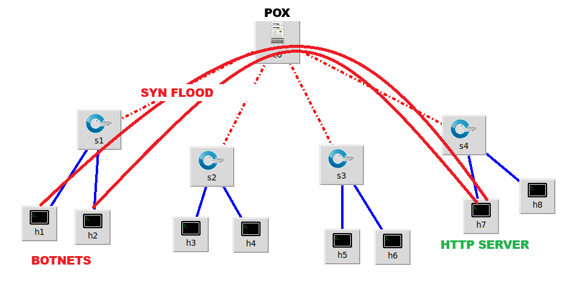

- Verification:
  - Wireshark: Capture and analyze the flood of SYN packets and the lack of responses from h1as before.
  - Ping Test: Observe timeouts when pinging h7 from another host (h4), confirming the DoS impact.
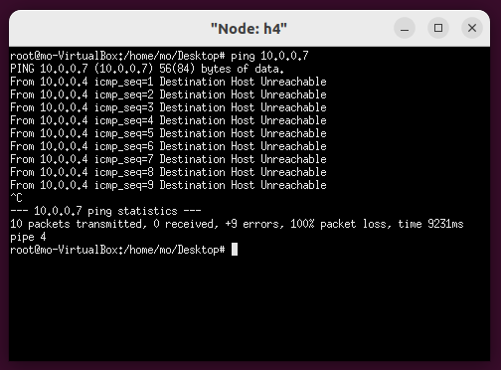
All packets are lost, this means that the impact of the attack is obvious were
h4 does not receive any reply from h7 because of the attack on it.
This detailed breakdown of the exploitation phase helps to clearly illustrate how the SYN flood attack disrupts the target's service, fitting into the overall kill chain model.
5. Installation
Goal: Install a backdoor or other persistent access mechanism.
- Note: For a DDoS attack, this stage may not apply since the goal is disruption rather than persistent access.
6. Command and Control (C2)
Goal: Establish command and control channels to communicate with the compromised system.
- Note: For a DDoS attack, this stage may not apply as there is no need for a C2 channel in a simple DDoS scenario.
7. Actions on Objectives
Goal: Achieve the attacker’s goals.
Action: Disrupt service on h7(http server) and the POX controller services.
Details: Monitor the effectiveness of the DDoS attack by pinging h7 from h4 to verify that packets are dropped as we see before and here is the detection using Wireshark when pinging on h7 by h4.
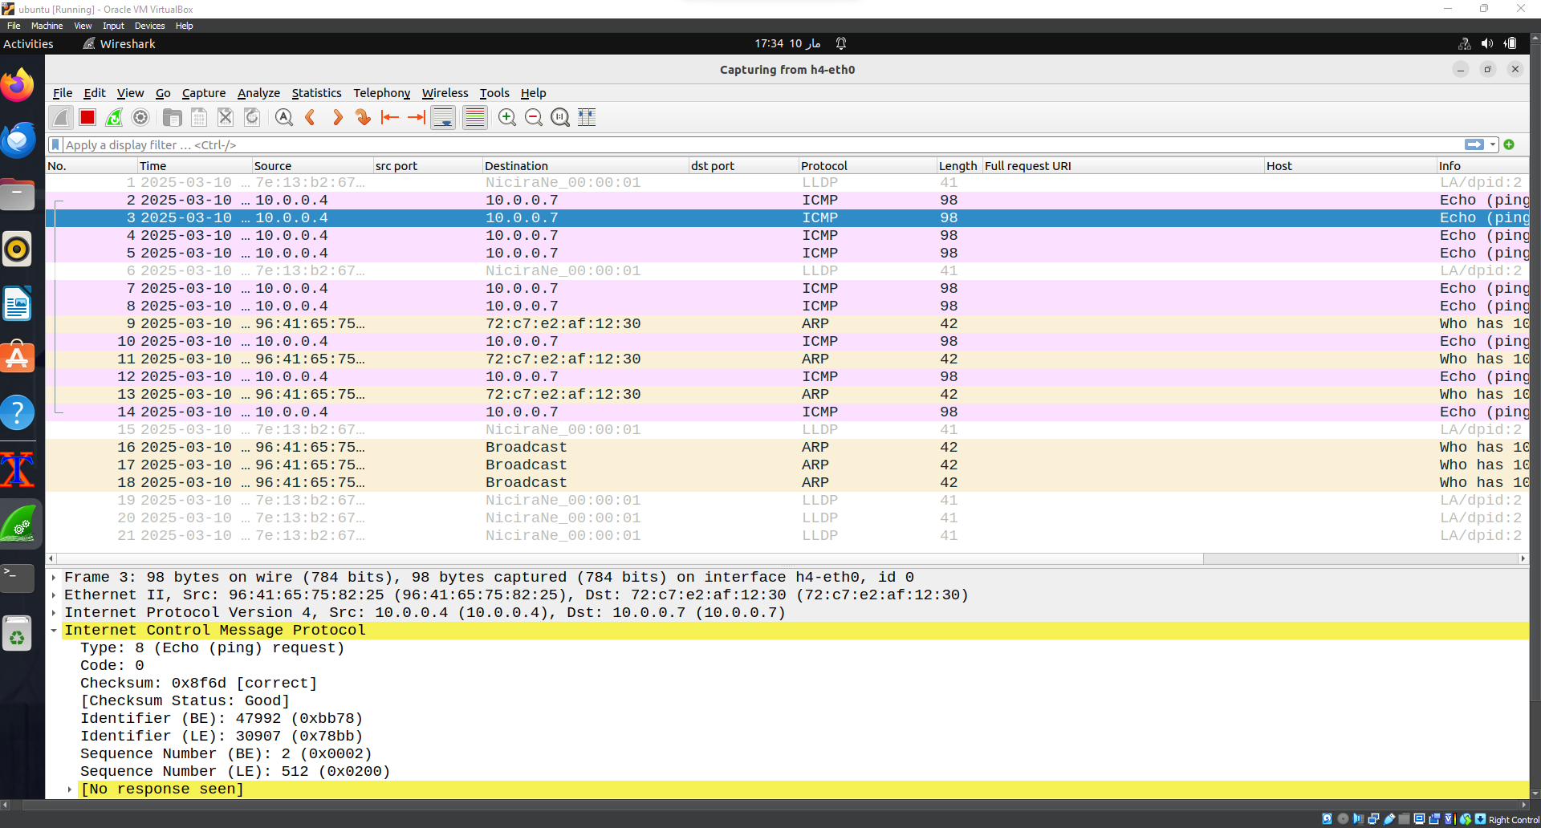
That means the controller can’t install the flows of the legitimate users in the network due to the attack and this means that the controller is corrupted.
Visualization in Kill Chain Model
Here is a summary visualization of your attack scenario within the Cyber Kill Chain model:
- Reconnaissance: Network scanning using nmap on h7 and POX.
- Weaponization: Preparing the hping3 payload.
- Delivery: Sending TCP packets from h1 and h2 to h7.
- Exploitation: Overwhelming h7’s resources and POX also.
- Installation: Not applicable.
- C2: Not applicable.
- Actions on Objectives: Disrupting h7’s service and POX also, verified by packet loss on h4.
Some notes when applying the Kill Chain Model in the SDN network using DDos:
Limited Quota of Open vSwitches During DoS Attack
During the implementation of the DoS attack using hping3, it is important to consider the limitations and behavior of the Open vSwitches (OVS) in our network. Here are some critical points to note:
- Limited Resource Quota:
  - Open vSwitches have a finite amount of resources (CPU, memory, and connection handling capacity).
  - A high volume of SYN packets can quickly exhaust these resources, leading to performance degradation or failure.
- Impact on Switches:
  - Overloading: The flood of SYN packets can overload the connection tables and other critical resources of the switches.
If we stop the host tracker we will see something like this
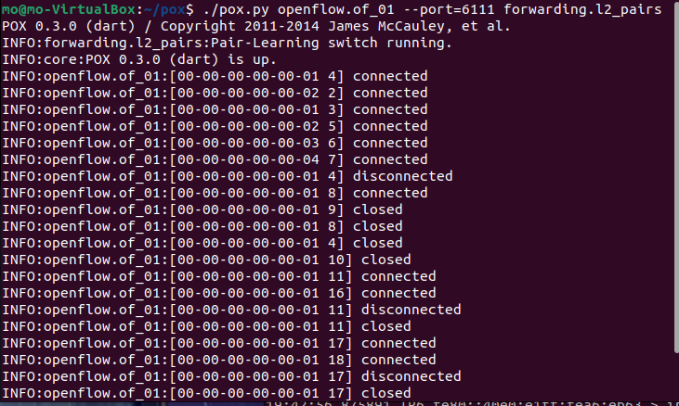
Disconnection: Overloaded switches may go down or become temporarily disconnected from the network.
3.Recovery post-attack:
Automatic Recovery: Once the DoS attack stops, the switches typically recover automatically.
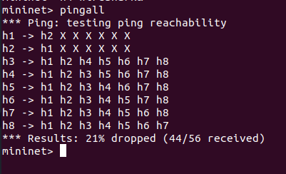
Resource Reallocation: The cessation of flood allows the switches to reallocate resources and resume normal operations.
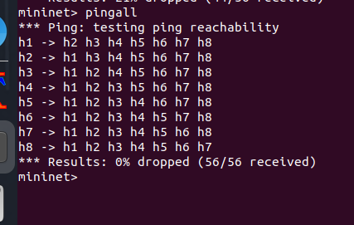
4. Observations During Testing:
Switch Down Events: During the attack, you may observe that several switches become unresponsive or disconnected as shown before.
Restoration: These switches should come back online and function correctly once the attack is mitigated.

Scenario
- During Attack:
  - Multiple OpenvSwitches go down due to resource exhaustion including the pox controller which is the mean objective here.
  - Network segments connected through these switches become temporarily disconnected.
- Post-Attack:
  - The switches recover and re-establish connections are also the controller.
  - Network functionality is restored without manual intervention.

